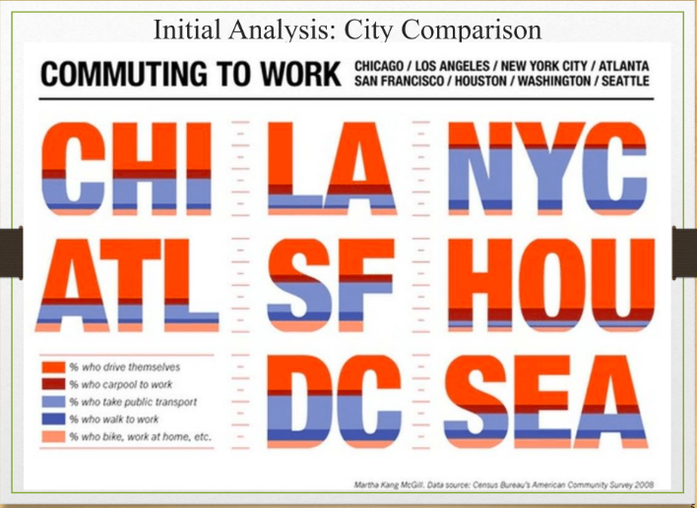

* Instead of looking at cities we can look at boroughs and see how different types of violations are dispersed within each borough
* The different types of ACE violations include:
  + Driving, standing or parking in a bus lane.
  + Standing or stopping in a bus stop.
  + Double parking along a bus route.
  + Waiting for passengers in a bus stop, bus lane or double parked on a bus route.